ASSIGNMENT NO.8: Views and Data Abstraction
Questions:
Q1) Create a MySQL database named CollegeDB and create two tables: Course and Student.
Course Table
Column Name | Data Type | Constraint
CourseID | INT | PRIMARY KEY
CourseName | VARCHAR(50) | NOT NULL
Fees | DECIMAL(10,2) | NOT NULL
Student Table
Column Name | Data Type | Constraint
StudentID | INT | PRIMARY KEY
StudentName | VARCHAR(50) | NOT NULL
CourseID | INT | FOREIGN KEY
City | VARCHAR(30)
Marks | INT
Email | VARCHAR(60)
Insert at least 4 course records and 10 student records.
QUERY:
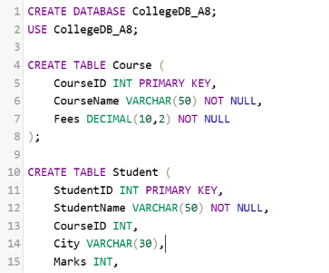

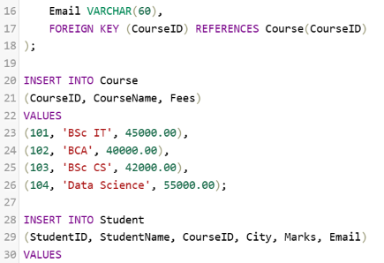
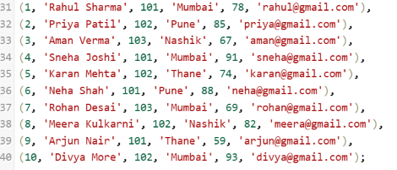

OUTPUT:
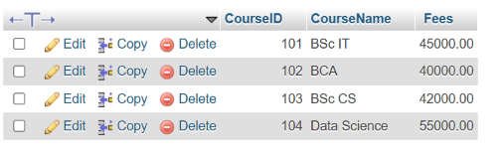
Q2) Create a view named StudentBasicView to display only selected student details.
The view should contain:
Column
StudentID
StudentName
Column
City
Marks

QUERY:
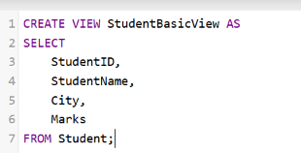

OUTPUT:
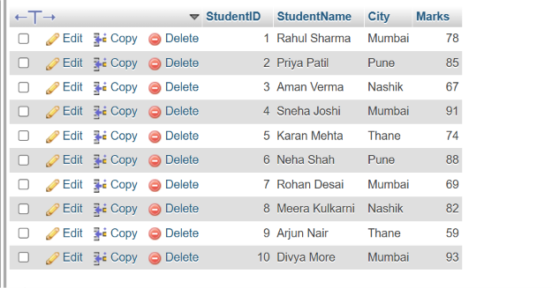

Q3) Create a view named StudentCourseView using Student and Course tables.
The view should display:
Column
StudentID
StudentName
City
Marks
CourseName
Fees

QUERY:
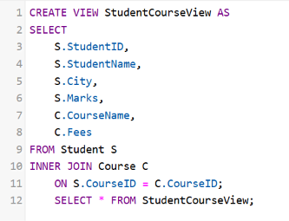

OUTPUT:
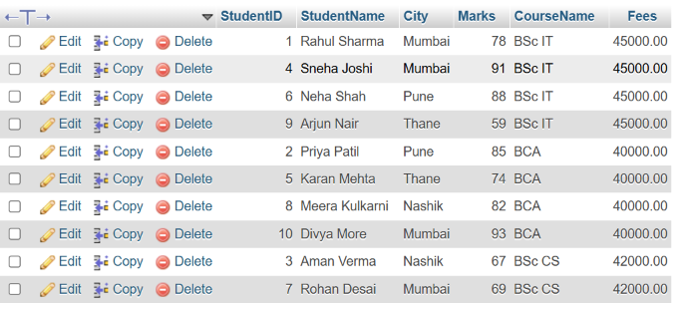
Q4) Write a MySQL query using StudentCourseView to display students from Mumbai. The output should contain:
Column
StudentName
City
CourseName
Marks

QUERY:
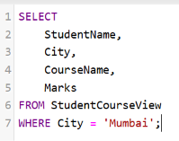
OUTPUT:
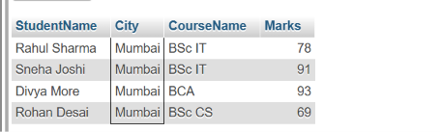

Q5) Write a MySQL query using StudentCourseView to display students sorted by marks in descending order.
The output should contain:
Column
StudentName
CourseName
Marks

QUERY:
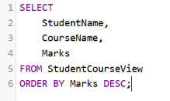

OUTPUT:
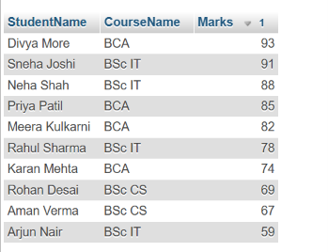

Q6) Create a report view named ManagementReportView.
The view should display course-wise summary:
Column
CourseName
TotalStudents
AverageMarks
LowestMarks
HighestMarks

Also write one line explaining why such a view is useful in reporting.

QUERY:
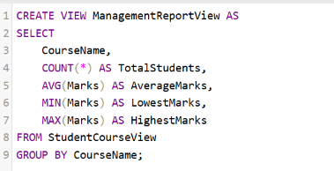
OUTPUT:


One-line explanation for Word:ManagementReportView is useful because it stores a reusable course-wise summary query for easy reporting and analysis

